**Questions Pattern.**

1. **Outside-in approach**
2. **Kano Model (Must have, Wants, Delighters)**
3. **State one metrics**
4. **Bottom 3 layers of product-market fit pyramid (Target customer, Underserved needs, Value proposition)**
5. **Peter Drucker's sources of innovation**
6. **Create a Lean canvas and Story map**
7. **Identify the top 2 HMW questions (How May We questions)**
8. **Mention 2 types of MVPs, Most suitable for product**

**Q. Study the journey of Netflix and identify:**

• **Key milestones**

**• Challenges faced**

**• What they did right and what they did wrong**

**• Key Product management learnings**

**Ans:** Netflix has been a dominant player in the streaming industry for over two decades. Here are some key milestones and challenges faced by Netflix along with their product management learnings:

**Key milestones:**

1997: Reed Hastings and Marc Randolph founded Netflix as a DVD-by-mail rental service.

2002: Netflix went public, allowing it to expand its DVD library and distribution centers.

2007: Netflix launched its streaming service, allowing users to instantly stream movies and TV shows to their computers.

2011: Netflix separated its DVD-by-mail service into a new company called Qwikster but later decided to keep both services under the Netflix brand.

2013: Netflix produced its first original series, House of Cards, marking the beginning of its investment in original content.

2016: Netflix expanded its service to over 130 countries, making it available in most countries worldwide.

2019: Netflix released the movie The Irishman, its most expensive production to date, with a budget of $160 million.

**Challenges faced:**

Competition: With the entry of new players like Amazon Prime, Hulu, and Disney+, Netflix faces fierce competition in the streaming market.

Content licensing: The cost of licensing content for streaming has increased, making it challenging for Netflix to maintain its library of popular movies and TV shows.

User acquisition: While Netflix has a large user base, it still faces challenges in acquiring new users in a market that is becoming increasingly crowded.

**What they did right and what they did wrong:**

Right: Investment in original content: Netflix's investment in original content has helped differentiate it from competitors and attract subscribers who are interested in exclusive content.

Right: Global expansion: By expanding its service to over 130 countries, Netflix has created a global audience, which has helped it scale rapidly.

Wrong: Qwikster: Netflix's decision to separate its DVD-by-mail service into a new company called Qwikster in 2011 was met with widespread backlash from subscribers and investors, leading to a loss of revenue and customers.

Wrong: Pricing changes: In 2011, Netflix increased its prices for streaming and DVD-by-mail services, leading to a significant loss of subscribers.

**Key product management learnings:**

Focus on customer needs: Netflix has been successful in understanding and meeting the needs of its customers by investing in original content, expanding globally, and providing personalized recommendations based on user behavior.

Be adaptable: Netflix has shown an ability to adapt to changing market conditions and shifting consumer behavior, such as the shift towards streaming and the move away from DVDs.

Pricing strategy: Netflix's pricing changes in 2011 highlight the importance of carefully considering the impact of pricing changes on customers and revenue before implementing them.

Data-driven decision making: Netflix's use of data to make decisions, such as investing in original content, demonstrates the importance of using data to inform product management decisions.

1. **WhatsApp and Signal Kano Model?**

Ans:

<https://medium.com/@csn289/exploring-the-value-proposition-of-whatsapp-and-signal-through-kano-model-cba9e64f7eb3>

Essentially, the Kano Model states that there is an inherent hierarchy in customer benefits that in turn, affect customer satisfaction.

* Must have
* Wants
* Delighters

When present, the **must-haves** don’t increase satisfaction by all that much, but when missing have negative satisfaction rates. These are the minimum attributes that need to be addressed by the product.

The performance-benefits are attributes that increase satisfaction as they keep getting added.

The delighters are attributes that increase satisfaction to a large extent when added.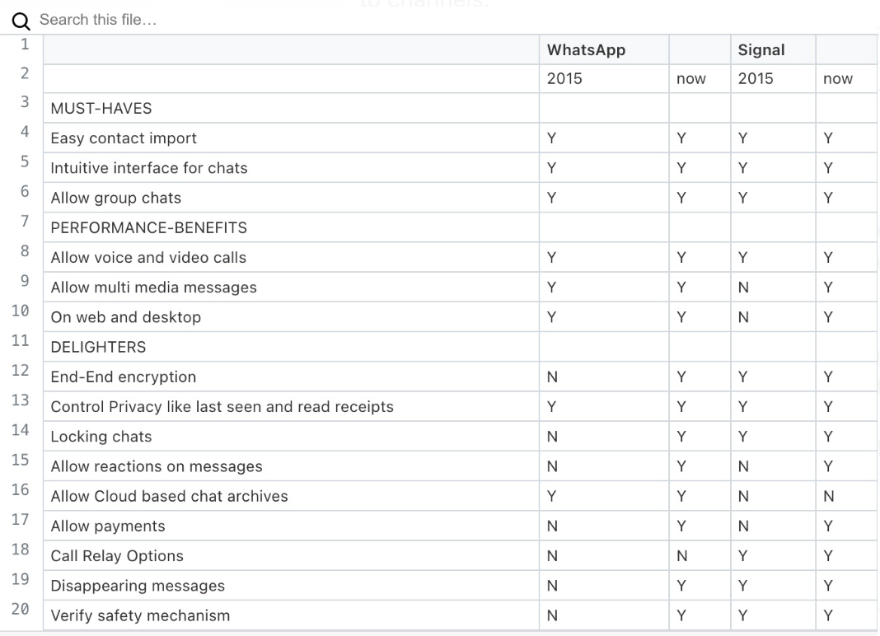

* The Kano model is a framework used to classify features of a product or service into three categories: **Must have, Wants, and delighter**. Here's how the features of WhatsApp can be classified using the Kano model:

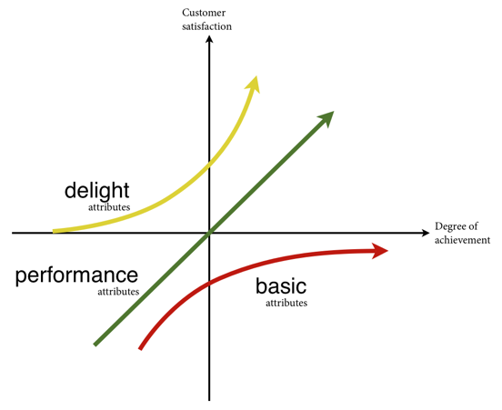

**Must have or Basic features:** These are the features that customers expect from a product or service, and their absence would lead to dissatisfaction**. In the case of WhatsApp, the basic features include:**

* Ability to send and receive text messages
* Ability to make voice and video calls
* Ability to send and receive photos and videos
* Group chat functionality
* End-to-end encryption for privacy and security

**Wants or Performance features:** These are the features that enhance customer satisfaction when they are present and their absence does not necessarily lead to dissatisfaction. **In the case of WhatsApp, the performance features include:**

* Ability to make voice and video calls with multiple people
* Ability to make payments through the app
* Ability to backup and restore chat history
* Ability to set customized wallpapers for chats

**Delighter features:** These are the features that surprise and delight customers when they are present, but their absence does not necessarily lead to dissatisfaction. **In the case of WhatsApp, the delight features include:**

* Animated stickers and emojis
* Ability to share GIFs and short videos
* Dark mode for the app
* Ability to send and receive voice messages

Overall, WhatsApp has a good balance of basic, performance, and delight features, which has contributed to its popularity as a messaging app. The basic features of WhatsApp are essential for its users, and the performance features add value and convenience. The delight features make the app more fun and engaging for its users.

1. **Wobot Intelligence?**

**Ans:** Wobot Intelligence is an Indian startup that provides AI-powered video analytics solutions for businesses. The company was founded in 2017 and is headquartered in Bangalore, India.

Wobot Intelligence's video analytics solutions use computer vision and machine learning algorithms to analyze video footage in real-time and provide insights and alerts to businesses. The solutions can be used for a variety of use cases, including security and surveillance, process optimization, and customer experience management.

**Some of the specific applications of Wobot Intelligence's solutions include:**

**Security and Surveillance:** Wobot's video analytics solutions can be used to monitor and detect security breaches, identify intruders, and track suspicious activity.

**Process Optimization:** The solutions can be used to monitor and analyze production lines, retail stores, and other business operations to identify bottlenecks, optimize workflows, and improve efficiency.

**Customer Experience Management:** Wobot's solutions can be used to monitor and analyze customer behavior in retail stores, restaurants, and other businesses to identify patterns, improve customer service, and optimize sales.

Wobot Intelligence's solutions are designed to be easy to use and can be integrated with existing security and surveillance systems. The company has received funding from several investors and has won several awards for its innovative video analytics solutions.

**Q. Which approach was used by Byju's learning Outside-in approach? Why do you say that?**

**Ans:** In the case of Byju's learning, the product discovery approach used was an **"outside-in" approach.**

Byju's learning is an edtech company that provides online learning resources for students. The company started by identifying a gap in the market for personalized, engaging, and effective learning resources that students could access from anywhere. They then developed a product that met those needs, with interactive videos, quizzes, and other features that make learning more engaging and effective.

The **"outside-in"** approach is a customer-centric approach to product development, where the focus is on understanding customer needs and preferences, and designing products that meet those needs. Byju's learning took this approach by **conducting extensive research and surveys to understand t**he pain points of students and parents in traditional learning methods, and then developed a solution that addressed those challenges.

**Q. illustrate the bottom 3 layers of product-market fit pyramid of DropBox offering.**

Ans: illustrate the bottom 3 layers of product-market fit pyramid of DropBox offering.

The product-market fit pyramid is a framework that helps companies achieve a good fit between their product and the market they serve. **The bottom three layers of the pyramid are:**

**Target customer:** This layer defines the specific group of customers that a product is designed to serve. For Dropbox, the target customers are individuals and small businesses who need a secure and reliable way to store, share, and access their files from anywhere.

**Underserved needs:** This layer identifies the unmet or underserved needs of the target customer. For Dropbox, the underserved need is a secure and easy-to-use file storage and sharing solution that does not require physical storage devices such as USB drives or external hard drives.

**Value proposition:** This layer defines the unique value that the product offers to the target customer. For Dropbox, the value proposition is a cloud-based file storage and sharing solution that is secure, reliable, and easy to use. It allows users to access their files from anywhere and share them with others without the need for physical storage devices.

To illustrate these layers, we can see how Dropbox has been designed to meet the needs of its target customers, individuals and small businesses. Dropbox provides a simple, secure, and easy-to-use cloud-based storage and sharing solution, **which solves the underserved need of not requiring physical storage devices. This value proposition has been key to Dropbox's success,** as it has made it easy for its target customers to store and share their files from anywhere, on any device.

Moreover, Dropbox has built its product around the needs of its target customers. It has a user-friendly interface, automatic syncing across devices, and integration with other popular apps and tools, all of which make it easy for individuals and small businesses to manage their files. This focus on the target customer and their underserved needs has helped Dropbox achieve a strong product-market fit and become a widely used and popular cloud-based file storage and sharing solution

**Q. Considering Peter Drucker's sources of innovation, which source of innovation led to SalesForce.com? Justify your answer.**

**Ans:**

Peter Drucker identified several sources of innovation, including:

* The unexpected
* Incongruities
* Process needs
* Industry and market changes
* Demographic changes
* Changes in perception
* New knowledge

Out of these sources of innovation, the one that led to Salesforce.com was the “**process needs”**.

Salesforce.com is a cloud-based software that provides customer relationship management (CRM) services to businesses. The company was founded in 1999 by Marc Benioff, Parker Harris, Dave Moellenhoff, and Frank Dominguez.

At that time, traditional on-premise CRM software was complicated, expensive, and required significant IT infrastructure. The founders of Salesforce.com recognized the need for a simpler, more affordable, and cloud-based CRM solution that could be accessed from anywhere with an internet connection.

They realized that companies needed a better way to manage their customer relationships without the complexity and cost of traditional CRM software. The team set out to create a solution that was easy to use, affordable, and accessible from anywhere.

By focusing on the process needs of businesses, Salesforce.com was able to disrupt the traditional CRM market and become a leader in cloud-based CRM software. The company's innovative approach to CRM has allowed businesses of all sizes to streamline their customer relationship management processes and improve their bottom line.

**In conclusion**, the source of innovation that led to Salesforce.com was the process needs of businesses. The company recognized that there was a significant need for a simpler, more affordable, and cloud-based CRM solution that could be accessed from anywhere. By meeting this need, Salesforce.com was able to disrupt the traditional CRM market and become a leader in cloud-based CRM software.

**Q. Considering peter druckers source of innovation, which source of innovation let to Rivigo? Justify your answer.**

**Ans:** Considering peter druckers source of innovation, which source of innovation let to Rivigo? Justify your answer.

Peter Drucker identified seven sources of innovation, which are:

* The unexpected
* Incongruities
* Process needs
* Industry and market structures
* Demographics
* Changes in perception
* New knowledge

Rivigo, an Indian logistics startup, seems to have been primarily driven by **"The unexpected**" source of innovation.

Rivigo was founded in 2014 with the aim of addressing the challenges faced by the logistics industry in India, such as high transportation costs, inefficient processes, and poor service quality. The founders of Rivigo, who had previously worked in the logistics industry, observed that the **traditional hub-and-spoke model of logistics was not well-suited to India's** unique geography and infrastructure challenges.

To overcome these challenges, Rivigo developed a new model of logistics, **called "relay trucking,"** which involved a network of drivers who drove in shifts to transport goods across long distances without stopping. This approach was unexpected, as it deviated from the traditional hub-and-spoke model and addressed the unique challenges of the Indian logistics industry.

Therefore, the unexpected source of innovation seems to have played a crucial role in the development of Rivigo's relay trucking model, which has disrupted the traditional logistics industry in India.

**Q. Illustrate 3 layers of product-market fit pyramid of DropBox offering?**

**Ans:**

**Target customer:**

**Underserved needs:**

**Value proposition:**

**Q. Kano model of DropBox offering?**

**Ans:** The Product Market Fit Pyramid is a framework that helps businesses assess whether their product or service meets the needs of their target market. Dropbox is a cloud storage and file-sharing service that allows users to store and access files from any device with an internet connection. Here's how the bottom 3 layers of the Product Market Fit Pyramid can be illustrated for Dropbox:

**Must-Have Features:**

The first layer of the Product Market Fit Pyramid is about identifying the must-have features that your target market needs. For Dropbox, these must-have features may include:

* Simple and easy-to-use interface for file sharing and collaboration
* Reliable and secure storage and access to files
* Integration with other apps and services that users are already using, such as Microsoft Office or Google Docs

**Wants features:**

The second layer of the pyramid is about customer satisfaction. This is where businesses must focus on meeting customer needs and exceeding their expectations. For Dropbox, this may include:

* Providing excellent customer service and support
* Continuously improving the user experience based on customer feedback
* Offering competitive pricing and flexible plans to meet the needs of different types of users

**Delighter features:**

The third layer of the pyramid is about expanding the product market. Once a business has established a strong product-market fit and satisfied its existing customers, it can focus on expanding its reach to new customers and markets. For Dropbox, this may include:

* Partnering with other businesses and services to reach new customers
* Expanding the product offerings to include new features and capabilities that appeal to different markets
* Targeting new customer segments, such as enterprise customers, by offering specialized services and features.

**Q. 3 layers of product market fit pyramid of gaana.com**

Ans:

**Target customer,**

**Underserved needs,**

**Value proposition**

**Q. Kano model of gaana.com**

Ans

Gaana.com is a popular music streaming service in India that offers a wide range of music in multiple languages. Here's how the bottom 3 layers of the Product Market Fit Pyramid can be illustrated for Gaana.com:

**Must-Have Features:**

The first layer of the Product Market Fit Pyramid is about identifying the must-have features that your target market needs. For Gaana.com, these must-have features may include:

* A vast collection of music in multiple languages and genres
* High-quality streaming and download options
* Personalized recommendations based on user listening habits
* Easy-to-use interface with features like playlists, radio, and offline listening

**Wants features:**

The second layer of the pyramid is about customer satisfaction. This is where businesses must focus on meeting customer needs and exceeding their expectations. For Gaana.com, this may include:

* Providing excellent customer service and support
* Regularly updating the platform to improve the user experience
* Offering a variety of subscription plans to meet the needs of different users
* Engaging with users through social media and other channels to understand their needs and preferences

**Delighter Features:**

The third layer of the pyramid is about expanding the product market. Once a business has established a strong product-market fit and satisfied its existing customers, it can focus on expanding its reach to new customers and markets. For Gaana.com, this may include:

* Partnering with other businesses and services to reach new customers and markets
* Expanding the music library to include more regional and international music
* Targeting new customer segments, such as music lovers in other countries, by offering specialized services and features.

**Q. Create a Lean canvas and Story map for an internet-based product that tells stories in an engaging way (audio only) to kids in the age group of 5 years.**

**Ans:**

**Lean Canvas:** Lean Canvas is recommended at this early stage. This was proposed by Ash Maurya. Helps get your idea(s) out from your head into a tangible format so that you can communicate that with others

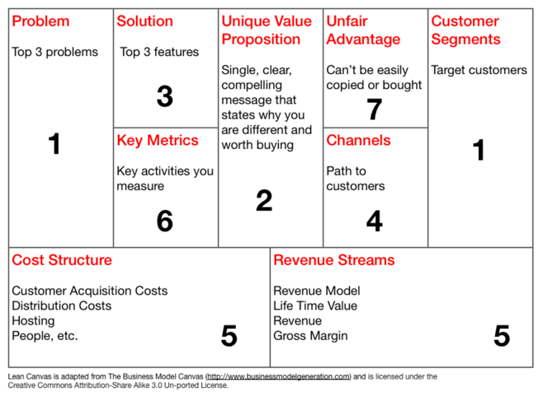

**Story Map:** Story map is an effective tool to capture the features. Once we have understood the need and we have assessed the need by interacting with customers & users, we need to capture all the requirements / features / functionality

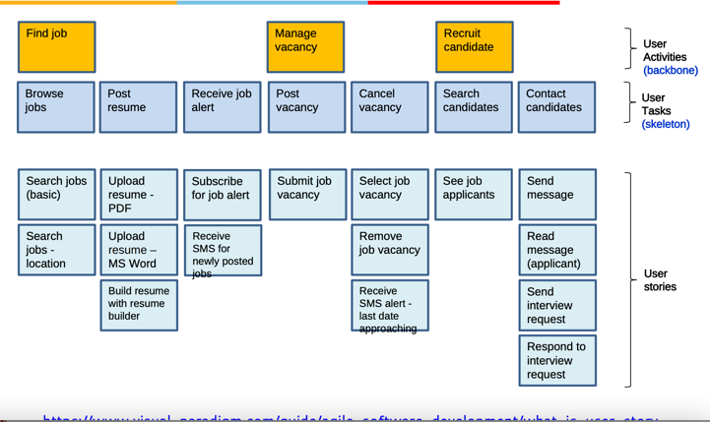

**Q. We would like to introduce a kid’s lock for the phone gallery as we don’t want children to see all the photos that we have captured using the Sprint technique.**

* **Map the usage of the product**
* **Identify the top 2 HMW questions (How May We questions) (Key questions that need to be answered to make the solution effective)**
* **Sketch the user interface of the solutions**

**Ans:**

**Who was on the sprint team?**

Keep the sprint team light.

• Facilitator — Me; A engineer and UX designer.

• Designer — Sharma:

• Test participant — Kumar; Tester

A **discovery sprint** is a one-week time box of product discovery work, designed to tackle a substantial problem or risk your product team is facing.

**Discovery coaches** are typically former product managers or product designers and they have usually worked for, or with, leading product companies.

**Day 1:**

**Understand**

Interview parents or guardians to understand their current methods for restricting their children's access to sensitive photos.

Identify the user personas, their goals, and their pain points**.**

**Day 2:**

**Define**

Consolidate the insights gained from user interviews and prioritize user needs.

Create a user journey map and define the core features of the kid's lock for the phone gallery.

**Day 3:**

**Sketch**

Sketch different interface solutions for the kid's lock for the phone gallery.

Narrow down to the best solution through group critique and feedback.

**Day 4:**

**Decide**

Decide on the final interface design.

Identify the technologies and tools needed to build the kid's lock software.

**Day 5:**

**Prototype**

Develop a prototype of the software.

Test the prototype with users and get feedback.

**Day 6:**

**Test**

Analyze the feedback and identify areas of improvement.

Iterate the prototype and test again.

**Usage of the Product:**

The kid's lock for the phone gallery will be used by parents or guardians who want to restrict access to certain photos on their phones. The lock will be activated by the parent or guardian and will require a password or other authentication method to unlock.

**HMW Questions:**

1. How may we ensure that the kid's lock is easy to set up and use, while still providing strong security measures to protect sensitive photos?
2. How may we provide a user-friendly interface that allows parents or guardians to select which photos to protect and which to leave accessible to their children?

**User Interface Sketch:**

Please find a sketch of the user interface for the kid's lock for the phone gallery here:

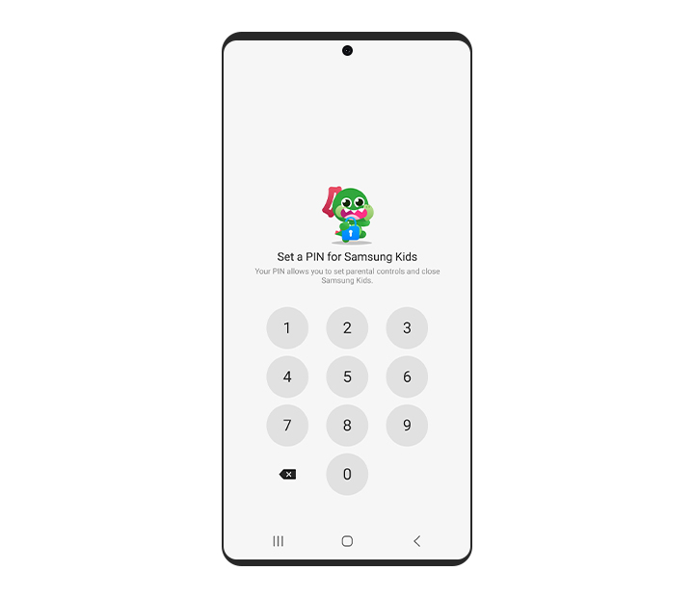

The interface will feature a lock icon in the gallery app that parents or guardians can tap to activate the kid's lock. Upon activation, a prompt will appear asking for a password or other authentication method to unlock the protected photos. Parents or guardians can then select which photos to protect by tapping on them and selecting the lock icon. The locked photos will appear blurred or with an overlay to indicate that they are protected. The interface will also allow parents or guardians to remove protection from photos if they wish to do so.

A **discovery sprint** is a one-week time box of product discovery work, designed to tackle a substantial problem or risk your product team is facing.

**Discovery coaches** are typically former product managers or product designers and they have usually worked for, or with, leading product companies.

**Who was on the sprint team?**

We kept the sprint team light..

* Facilitator — Me; A engineer certified UX Director.
* Designer — Sharma:
* Test participant — Kumar; Tester

## ****What question did you want to answer in your sprint?****

1. **Starting with empathy**

Empathy is when we can understand what it might be like for other people. If we empathies with someone it means we understand how they think and feel about something.

1. **Defining the problem**
2. **Coming up with ideas**
3. **Making a prototype**

Sketch the user interface of the solutions

1. **Testing the prototype**

**Q. We would like to Develop a web-based news reading software that caters to people with verifying interests. Some maybe interested in politics, some may be interested in Sports, some in business, etc. and some may be in a combination of these domain. Use the Sprint technique.**

* **Map the usage of the product**
* **Identify the top 2 HMW questions (How May We questions) (Key questions that need to be answered to make the solution effective)**
* **Sketch the user interface of the solutions**

**Ans:**

Sprint Technique for Web-Based News Reading Software:

**Day 1:**

Understand

Interview target users to understand their current news reading habits, preferences, and pain points.

Identify the user personas, their goals, and their pain points.

**Day 2:**

Define

Consolidate the insights gained from user interviews and prioritize user needs.

Create a user journey map and define the core features of the news reading software.

**Day 3:**

**Sketch**

Sketch different interface solutions for the news reading software.

Narrow down to the best solution through group critique and feedback.

**Day 4:**

**Decide**

Decide on the final interface design.

Identify the technologies and tools needed to build the software.

**Day 5:**

**Prototype**

Develop a prototype of the software.

Test the prototype with users and get feedback.

**Day 6:**

**Test**

Analyze the feedback and identify areas of improvement.

Iterate the prototype and test again.

**Usage of the Product:**

The web-based news reading software will cater to people with varying interests in different domains such as politics, sports, business, entertainment, etc. Users will be able to customize their news feed based on their interests and preferences. They will also have access to a range of sources for each category and will be able to curate their news feed according to the specific sources they trust.

**HMW Questions:**

1. How may we provide a personalized news feed that caters to the user's interests while ensuring that they also receive a well-rounded perspective of the news?
2. How may we ensure that the news feed is free from bias and provides accurate and verified information?

**User Interface Sketch:**

Please find a sketch of the user interface for the news reading software here:

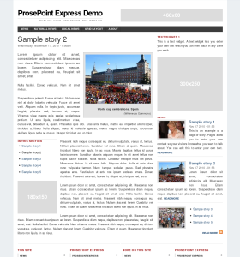

The interface will feature a dashboard that displays different categories of news such as politics, sports, business, entertainment, etc. Users will be able to select their preferred categories and sources and will be able to curate their news feed according to their preferences. The interface will also provide options for users to access news by location and language. The news feed will display headlines, summaries, and images for each article, and users will be able to click on each article to read more. The interface will also feature a search bar that users can use to look for specific topics or keywords. Additionally, the interface will provide a user-friendly way to report any inaccuracies or bias in the news feed.

**Q. Assume Zoom Video conferencing product is at the startup stage.**

**Mention 2 types of MVPs that can be considered for this product.**

**Explain these 2 MVPs are the most suitable for this product.**

Ans:

**Zoom Mobile and Desktop App.** A single, unified platform for Meetings, Phone, and Team Chat on Windows, Apple MacOS, Apple iOS and Google Android devices.

* Desk Phone Support.
* Video Conferencing
* Audio Conferencing
* Group Collaboration Features
* Call Recording
* Call Forwarding
* Call Transfer.
* Web Conferencing Features

**Here are two possible types of Minimum Viable Products (MVPs) that could be considered for a video confer**encing product, including why they may be suitable:

**Basic Video Conferencing Functionality MVP:** This MVP would include the basic functionality required for video conferencing, such as the ability to join and host meetings, share screens, and send chat messages. This MVP would provide users with a simple and reliable way to connect and collaborate remotely. As video conferencing has become an essential tool for remote work and communication, this MVP could be a suitable starting point to test the product's viability and generate user feedback.

**Virtual Backgrounds MVP:** This MVP would focus on a unique feature that sets the product apart from competitors, such as the ability to add virtual backgrounds during a video call. This MVP would allow users to change their background to an image or video, such as a beach or office, to create a more professional or fun setting. This MVP would appeal to users who are looking for a more engaging and personalized video conferencing experience. By providing a unique and differentiated feature, this MVP could help the product stand out in a crowded market and attract early adopters.

Both MVPs could be suitable for Zoom Video conferencing, depending on the product's stage and goals. The basic video conferencing functionality MVP is a practical starting point that provides essential features to users, while the virtual backgrounds MVP adds a unique and differentiated feature that could appeal to specific user segments. Ultimately, the choice of MVP will depend on the product's overall strategy and target market.

**Q. Describe a software product that you use regularly at office or for personal use.**

**a) Rate the learnability, efficiency and error dimensions of usability of this product on a scale of 1 to 5. Justify your answers.**

**b) Rate the conceptual design and information architecture of this product on a scale of 1 to 5. Justify your answer.**

**Ans:**

One software product that I frequently use at work is **Microsoft Excel.**

**a) In terms of learnability,** I would rate Excel a 4 out of 5. The basic functions and features are easy to grasp, but more advanced functions can be difficult to learn without some training or experience. However, Microsoft provides many resources for learning Excel, including online tutorials, help articles, and community forums, which make it easier to learn.

**In terms of efficiency,** I would rate Excel a 5 out of 5. It is an extremely efficient tool for managing and analyzing data, and once you know how to use it, it can save a lot of time and effort compared to manual data management. The ability to create and use templates, macros, and pivot tables further enhances its efficiency.

**In terms of error,** I would rate Excel a 4 out of 5. While it is generally reliable and accurate, there is a potential for errors to occur if the user does not input data correctly, or if formulas are not used properly. However, Excel has built-in error-checking tools, such as the ability to check for errors and trace formula dependencies, which helps to mitigate these risks.

**b) In terms of conceptual design and information architecture,** I would rate Excel a 4 out of 5. Its interface and layout are generally user-friendly, with the ability to easily switch between sheets, customize the toolbar, and access commonly-used functions. However, some of the more advanced features can be buried within menus and submenus, which can make it difficult to find them without prior knowledge. Overall, Excel's design and architecture are effective in helping users manage and analyze data efficiently.

**Q. Apple iPod "outside-in" approach.**

**Ans:**

The product discovery approach used for the development of the Apple iPod was an **"outside-in"** approach.

The **"outside-in" approach** is a customer-focused approach to product development. In this approach, the development team starts by identifying customer needs and desires, and then works to develop a product that meets those needs. This approach contrasts with an "inside-out" approach, in which the development team starts with the features and capabilities of a product, and then tries to find a market for it.

**In the case of the iPod**, Apple started by identifying a gap in the market for a portable, easy-to-use music player that could store large amounts of music. They then developed a product that met those needs, with a user-friendly interface and the ability to store thousands of songs in a small, lightweight device. This customer-centric approach helped the iPod become a hugely successful product.

**Q. Paytm Kano Model?**

**Ans:**

The Paytm Kano Model is a framework used by Paytm, an Indian digital wallet and e-commerce company, to prioritize features and improve customer satisfaction. The Kano Model was developed by Japanese researcher Noriaki Kano in the 1980s and is widely used in product development and customer satisfaction research.

The Kano Model categorizes features into three types: **Must have features, Wants features, and delighter features.** Basic features are expected by customers and their absence leads to dissatisfaction, but their presence does not necessarily lead to satisfaction. Performance features are those that customers explicitly ask for and their presence leads to satisfaction, while their absence leads to dissatisfaction. Excitement features are unexpected and their presence leads to high levels of customer satisfaction and delight, but their absence does not necessarily lead to dissatisfaction.

Paytm uses the Kano Model to **prioritize features for its digital wallet and e-commerce platform.**

* **Must have features** include fast and reliable payment processing.
* **Wants features** include the ability to make payments to a variety of merchants and access to offers and discounts.
* **Delighter features** may include personalized recommendations and offers based on customer behavior.

By using the Kano Model, Paytm can prioritize its product development efforts and focus on features that will lead to the highest levels of customer satisfaction. Additionally, the Kano Model can help Paytm identify areas where it may be falling short in meeting customer expectations and where improvements can be made to increase customer satisfaction.

**Q.** **Assume Paytm is at the startup stage.**

**Mention 2 types of MVPs that can be considered for this product.**

**Explain these 2 MVPs are the most suitable for this product.**

**Ans:**

Two types of MVPs that Paytm could consider are:

**Landing Page MVP:** This type of MVP involves creating a simple landing page that showcases the product or service and collects user information such as Mobile number/Email id. The landing page can include a brief explanation of the product, its benefits, and features, and an invitation to sign up for updates or early access.

**Concierge MVP:** This type of MVP involves manually providing the core service of the product to a small number of customers. This allows the company to test the demand for the product and identify key features that need to be developed. The concierge MVP can involve a manual process to provide the service, such as using human resources to complete the transactions and customer service interactions.

Both of these MVPs are suitable for Paytm because they allow the company to test the demand for their product while keeping costs low. The landing page MVP is suitable if Paytm is still in the early stages of developing the product and wants to validate the market demand for it. This type of MVP is also useful for building an Mobile number/email list of potential customers to target in future marketing campaigns.

The concierge MVP is more suitable if Paytm has already developed a basic version of the product and wants to test it with real customers. By providing a manual service to a small number of customers, Paytm can identify any pain points or issues that need to be addressed before scaling up the product. The concierge MVP also allows Paytm to collect feedback from customers and iterate on the product before investing in building a full-scale automated version.

**Q. Rivigo and Move works**

**Ans:**

**Lean Canvas:**

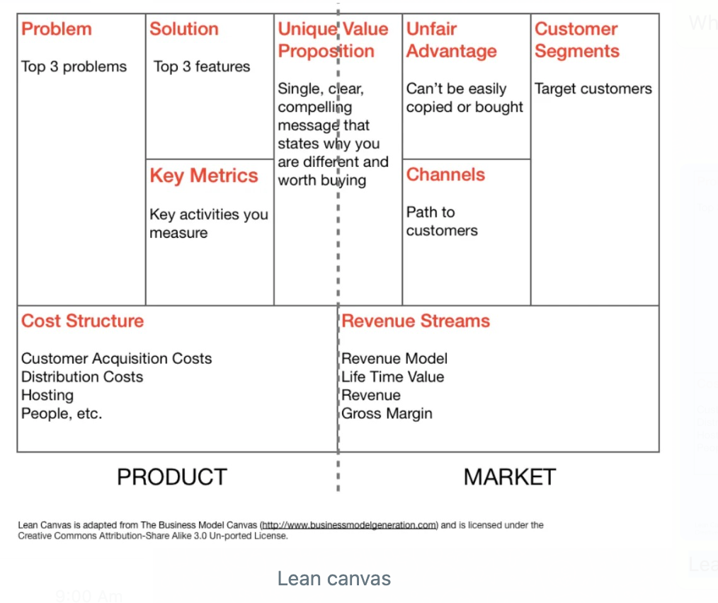

**Q. Classify the features of YouTube Kano model.**

**Ans:**

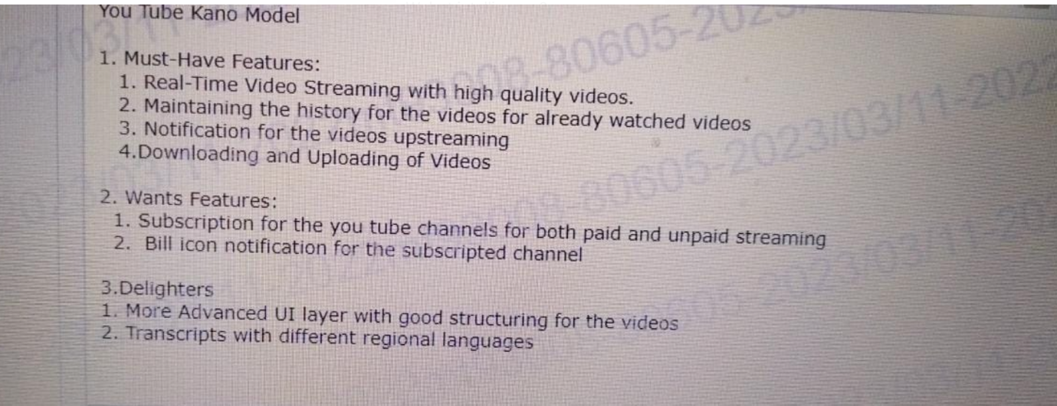

Kano Model is a customer satisfaction framework used to classify the features of a product into three categories: basic, performance, and excitement. Here's how YouTube's features can be classified using the Kano model:

**Must-have Features:** These are the essential features that customers expect to be present in the product. Without these features, the product would not function as intended, and customers would be dissatisfied. Examples of basic features of YouTube include:

* The ability to search for and watch videos
* Ability to subscribe to channels and create playlists
* Ability to like, dislike, and comment on videos
* Ability to share videos on social media platforms
* Ability to adjust video quality based on internet connection

**Wants Features:** These are features that improve customer satisfaction when they are present, but their absence does not necessarily cause dissatisfaction. These features are often related to the quality of the product. Examples of performance features of YouTube include:

* The ability to play videos in HD or 4K
* Faster video loading times and less buffering
* Personalized video recommendations based on user watch history and preferences
* Integration with Google services such as Google Drive and Google Home

**Delighter Features:** These are features that customers may not expect, but when they are present, they create a positive surprise and lead to increased satisfaction. Excitement features are often related to innovation and creativity. Examples of excitement features of YouTube include:

* Virtual reality videos and 360-degree videos
* Live streaming of events and concerts
* YouTube Originals, exclusive shows and movies produced by YouTube
* Interactive features such as annotations, cards, and end screens that add interactivity to videos.

Overall, the Kano model can help companies like YouTube understand which features are most important to their customers and prioritize their development efforts accordingly.

**Q. Twilio case study?**

**Q. Netflix case study?**

**Q. DBS Bank case study?**

**Q. Qalara case study?**

**Q. Innovation ideas from ID Foods – Mustafa case study?**

**Q. Case study**

Differentiation –

**Intuit** – UI and features –

**Apple** – UX –

**Citibank**– Reliability & infrastructure –

.**Net** – Ease of use –

**Toyota** – Quality –

**ISRO** – low cost satellite launches for world-wide customers – • Entry barrier –

**Google Earth –** Entry barrier due to technology –

**Da Vinci Robotic surgery** – Technology – Microsoft

**HoloLens** – Mixed reality technology for doctors, etc

**Creating Partnerships & alliances**

• **Xerox** tied up with paper manufacturers to ensure steady supply of paper

• **SAP partners:** DataXtream for POS solutions, DocuSign for eSignature integration with SAP

• **Netflix tied up** with telecom service providers such as Verizon, Airtel to host their content at ISP gateways, so as to ensure fast response time to customers

• **MakeMyTrip built** alliances with Airlines, hotels, etc.

• Any other examples you have come across

**Product should address the total customer experience (the whole offer)**

• **Kaagaz & MS Office Lens** (document scanner app on mobile) does not only scan but allows us to share the image via email, WhatsApp etc. Because the customer is not just interested in scanning and storing, he wants to share with others

• **Xerox started with photo** copying facility but soon realized people need to staple the pages, need cover page in different colour, etc. So they enhanced the machine to address the total customer experience

• **Clarify:** customer support software that involves tracking customer interaction, product details, knowledge base, workflows

• **No Broker.com: Find** house, pay advance, get painter, get packer & mover

• Have you come across other products that address total customer experience?

• **Oyo:** Economy hotels were not clean, lacked basic amenities, etc.

• **Sketch:** Observed that Photoshop was not easy to use

• **Slack:** Collaboration between teams was clumsy

• **Spotify:** People wanted to listen to music legally when illegal music sharing sites were banned

**Ola cabs:** Founder was travelling in a cab and cab driver demanded exorbitant amount to change the destination

• **DropBox:** Founder kept forgetting to carry files in pen drive

• **Tally:** Experienced that existing accounting packages had a User interface that catered to accounts / finance professional. But not to non-finance folks

Examples:

– **Shampoo** sachet for Re.1

– **Micro credits to** rural people to buy a sewing machine, a cow to start milk business, etc. It was observed that default by rural people is significantly less compared to urban people because of the fear of o

**– Jio, Nirma** are other examples of targeting the bottom of the pyramid

**Q. Consider your current job & company Think about the unmet / underserved needs of your customers Give one example of such a need & its compelling value / benefit to customer.**

Ans:

I work for a software company that provides a project management tool for teams. One unmet need of our customers might be **the ability to easily track and manage project budgets.** While there are other project management tools on the market that offer budget tracking, our customers have expressed frustration with the lack of flexibility and ease-of-use in these existing solutions.

**To address this need,** we could develop a budget tracking feature that allows project managers to easily create and manage project budgets within our software. This feature could include customizable budget templates, the ability to set budget thresholds and alerts, and real-time budget tracking and reporting.

**The compelling value** of this feature would be that it provides our customers with greater visibility and control over their project finances, helping them to better manage costs and avoid budget overruns. This would not only improve the overall project success rate but also help the customer to be more profitable and competitive in the marketplace.

**Additionally,** having a budget tracking feature within our software could differentiate us from competitors and attract new customers who are seeking a comprehensive project management tool with robust budget tracking capabilities.

**Q. Define value: Exercise**

**Product, OYO find the Pain point, How does it solve, Benefit or Value proposition, Differentiation from competition.**

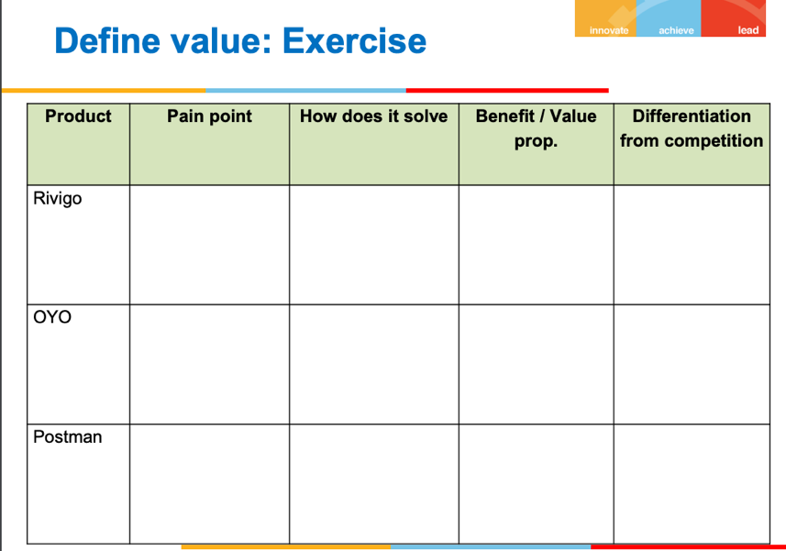

**Q. Product, OYO find the Pain point, How does it solve, Benefit or Value proposition, Differentiation from competition**

**Ans:**

**Product:** OYO Rooms

**Pain Point:**

The pain point that OYO addresses is the lack of standardized and reliable budget accommodations in the hospitality industry. Before OYO, budget travelers often had to compromise on quality and safety in order to find an affordable place to stay. They were forced to rely on unverified reviews, which made the process of booking budget hotels uncertain and risky.

**How it solves:**

OYO addresses this pain point by partnering with small, budget hotels and transforming them into standardized and branded accommodations. OYO provides hotel owners with technology-enabled tools and services, including property management systems, revenue management, and online distribution, to improve the quality of their rooms and services. OYO also standardizes the guest experience by providing a consistent design and service across all of its properties.

**Benefit or Value Proposition:**

The value proposition of OYO is to provide budget travelers with a reliable, standardized, and consistent accommodation experience. By partnering with small hotels and improving their quality, OYO is able to offer affordable rooms without sacrificing quality or safety. The technology-enabled tools and services provided by OYO help hotel owners to improve their revenue and occupancy rates while also delivering a better guest experience.

**Differentiation from competition:**

OYO differentiates itself from other budget hotel providers by focusing on standardization and consistency. OYO provides a consistent design and service across all of its properties, which helps to build trust and loyalty among customers. OYO's technology-enabled tools and services also differentiate it from competitors, as they help to improve the quality of the accommodations and the revenue management of the hotels. Finally, OYO's rapid expansion into international markets, particularly in Asia, has helped it to gain a foothold in markets that are underserved by other budget hotel providers.

**Q. Product Postman find the Pain point, how does it solve, Benefit or Value proposition, Differentiation from competition.**

**Ans:**

**Product: Postman**

**Pain Point:**

The pain point that Postman addresses is the difficulty of testing and integrating APIs (Application Programming Interfaces) in software development. Prior to Postman, developers had to manually test APIs using a combination of tools and scripts, which was time-consuming and error-prone. Additionally, many developers were not familiar with the nuances of API testing and integration, which made it a challenging task.

**How it solves:**

Postman addresses this pain point by providing a comprehensive API testing and integration platform. Postman offers an intuitive user interface for designing, testing, and documenting APIs, as well as a suite of tools for collaborating and sharing API collections with team members. Postman also provides automation capabilities for API testing and integration, reducing the time and effort required for these tasks.

**Benefit or Value Proposition:**

The value proposition of Postman is to simplify and streamline the process of API testing and integration. By providing a comprehensive platform with an intuitive user interface, Postman makes it easier for developers to test APIs and identify issues early in the development process. Postman's collaboration and automation features also help to improve team efficiency and reduce time-to-market.

**Differentiation from competition:**

Postman differentiates itself from other API testing and integration tools by offering a comprehensive platform with an intuitive user interface and automation capabilities. Postman's user interface is designed to be user-friendly and accessible, even for developers who are not familiar with API testing and integration. Additionally, Postman offers a suite of collaboration and sharing tools that make it easier for teams to work together on API development projects. Finally, Postman's automation capabilities, including pre-built integrations with popular CI/CD tools, help to streamline the development process and reduce the risk of errors.

**Q. ‘Mom Test’: How to ask the right questions to assess a product idea?**

**Ans:**

The "Mom Test" is a framework for asking the right questions to assess a product idea, without receiving biased or overly positive feedback from friends and family. Here are some tips for asking the right questions:

**Focus on the problem:** Instead of asking if someone would use your product, ask if they have experienced the problem that your product solves. This helps to validate the problem and ensure that there is a real need for your product.

**Avoid leading questions:** Be careful not to ask questions that lead the person to give a positive response. For example, instead of asking "Wouldn't it be great if there was a product that solved this problem?" ask "Have you tried any products that solve this problem?"

**Ask about specifics:** Ask about specific instances where the person has experienced the problem, how often it occurs, and what they have done to try to solve it. This helps to uncover more detailed insights into the problem and potential solutions.

**Don't defend your idea:** Resist the urge to defend your idea or argue with the person's feedback. Instead, ask follow-up questions to better understand their perspective and concerns.

**Ask for feedback, not validation:** Finally, ask for honest feedback and suggestions for improvement. This helps to identify areas where your idea may need refinement or further development.

By following these tips, you can conduct effective interviews and get valuable insights into your product idea without receiving biased or overly positive feedback. This can help you to better understand the needs of your target market and develop a product that truly solves their problem.

**Q. Kano model, identify ‘Must have’, ‘Wants’ & ‘Delighter’ features of Online banking**

**Ans:**

The Kano model is a framework for categorizing customer preferences into three main categories: Must-Have, Wants, and Delighters. Here are some examples of features for an online banking platform that fall into each category:

**Must-Have Features:** These are features that customers expect to be present and are taken for granted. If these features are not included, customers may be dissatisfied and may not use the product.

* Secure login and authentication
* Account balance and transaction history
* Bill payment and transfer functionality
* Customer support and contact information
* Mobile app compatibility

**Wants Features:** These are features that customers desire but may not necessarily expect. They are features that can differentiate a product from competitors and increase customer satisfaction.

* Personal financial management tools (e.g. budget tracking, spending analysis)
* Enhanced security features (e.g. two-factor authentication, biometric login)
* Customizable dashboard and alerts
* Integration with third-party apps and services (e.g. Venmo, PayPal)
* Rewards program or cashback offers

**Delighters Features:** These are features that go above and beyond customer expectations and can create a "wow" factor. These features can surprise and delight customers, leading to increased loyalty and word-of-mouth referrals.

* Voice-controlled banking (e.g. using Alexa or Google Home)
* Virtual financial assistant for personalized financial advice
* Augmented reality for viewing account information and transactions
* Personalized recommendations for financial products and services
* Virtual reality tours of bank branches and services

By using the Kano model to categorize features, online banking platforms can prioritize their development efforts and focus on creating the most value for their customers.

**Q. Kano model, identify ‘Must have’, ‘Wants’ & ‘Delighter’ features of Airline reservation**

**Ans:**

Here are some examples of features for an airline reservation system that fall into each category of the Kano model:

**Must-Have Features:**

* The ability to book a flight
* Seat selection
* Check-in and boarding pass retrieval
* Flight status updates
* Cancellation and refund policies

**Wants Features:**

* In-flight entertainment
* Wi-Fi connectivity
* Loyalty program benefits
* Ability to choose meal preferences
* Mobile boarding passes

**Delighter Features:**

* Complimentary upgrades to business or first class
* Personalized in-flight experiences based on passenger preferences
* Virtual reality tours of the aircraft and cabin amenities
* 24/7 customer support through chat or video call
* Priority boarding and baggage handling

By using the Kano model to categorize these features, airlines can prioritize their development efforts and focus on creating the most value for their customers. For example, by ensuring that all must-have features are present and functioning smoothly, airlines can avoid customer dissatisfaction and lost revenue due to failed transactions or unhappy customers. By investing in delighter features, airlines can differentiate themselves from competitors and create a unique customer

**Q. Kano model, identify ‘Must have’, ‘Wants’ & ‘Delighter’ features of eCommerce**

**Ans:**

Here are some examples of features for an eCommerce platform that fall into each category of the Kano model:

**Must-Have Features:**

* Product search and filters
* Add to cart and checkout functionality
* Payment gateway integration
* Order tracking and delivery status updates
* Customer reviews and ratings

**Wants Features:**

* Personalized product recommendations
* Guest checkout option
* User account and wishlist functionality
* Loyalty program benefits
* Social media integration for sharing and promoting products

**Delighter Features:**

* Augmented reality for trying on clothing or visualizing products in the home
* 24/7 customer

**Q. Create story map for Hotel booking software?**

**Ans:**

Classification of product features:

• Must have

• Wants

• Delighters

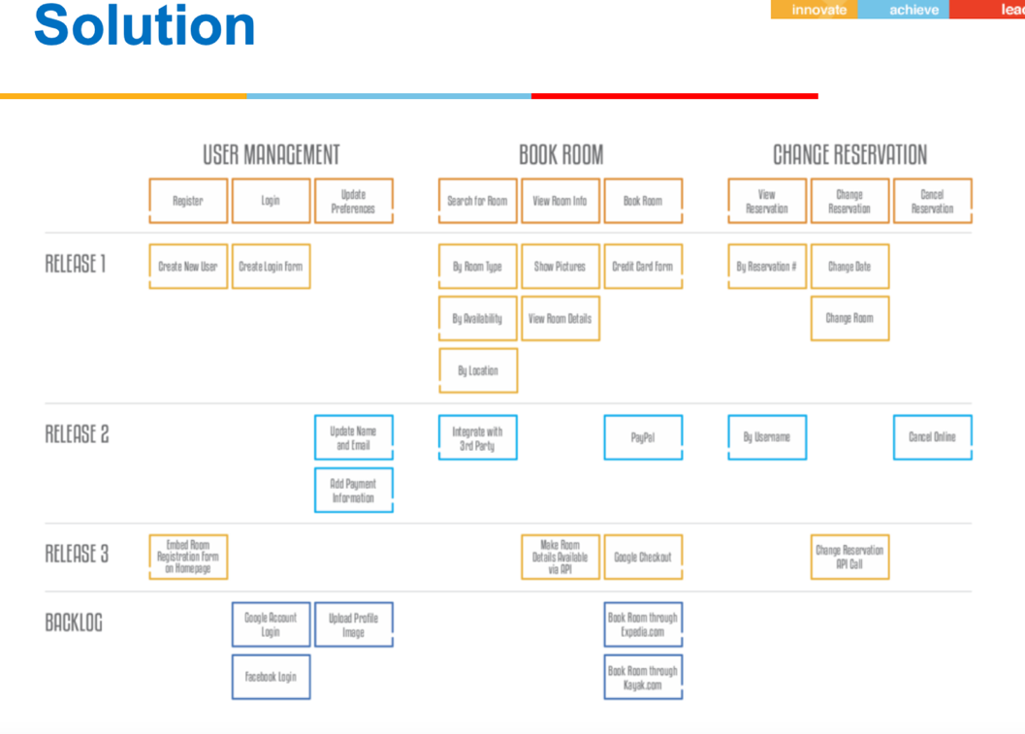

Here is a high-level story map for a hotel booking software:

Epic 1: User searches for a hotel

Story 1: User enters search criteria (e.g. location, dates, number of guests)

Story 2: User views search results (e.g. hotels available, prices, ratings)

Story 3: User filters search results (e.g. by price, amenities, distance from attractions)

Story 4: User selects a hotel to book

Epic 2: User books a hotel

Story 1: User enters guest information (e.g. name, email, phone number)

Story 2: User selects room type and enters payment information (e.g. credit card)

Story 3: User confirms booking and receives a confirmation email

Story 4: User has the option to cancel or modify the booking

Epic 3: Hotel management

Story 1: Hotel staff can manage room availability and rates

Story 2: Hotel staff can view and manage guest reservations

Story 3: Hotel staff can view booking reports and analytics

Epic 4: Additional features

Story 1: User can leave a review and rating of the hotel

Story 2: User can view nearby attractions and activities

Story 3: User can view and manage past and future bookings

Story 4: User can receive personalized recommendations based on past bookings and preferences

This story map outlines the major user stories and features of a hotel booking software. It includes functionality for searching and booking hotels, managing reservations and rates, and additional features such as reviews and personalized recommendations. This story map can be further refined and expanded upon based on user needs and feedback.

**Q. Classification of features of Laptop?**

**Ans:**

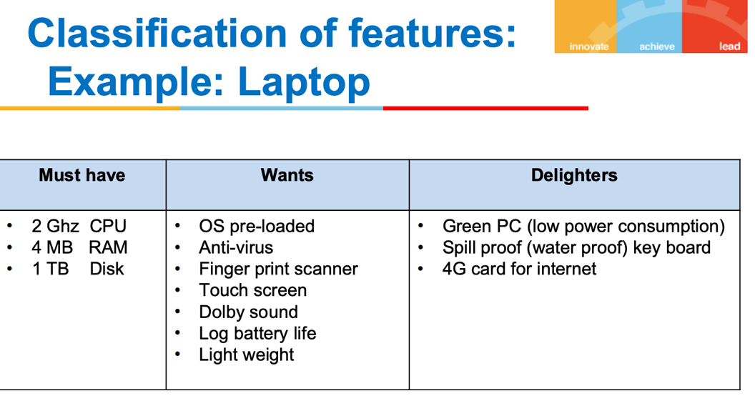

**Q. Design a set of interview questions to assess the following product idea**

**a) Online book library for students - technical & management books that allows student to borrow & read digital books (similar to Spotify) (B2C)**

**Ans:**

– Pain point: Students need to refer to many books. But only some parts of the book are useful. Buying the whole book is not value for money

– Solution:

• Tie-up with publishers to make books available online

• Students pay a monthly subscription • Students get to borrow 5 books at a time and read them online

• Publishers gets commission based on books borrowed and the duration the book was used

**Q. Design a set of questions to validate the following product idea**

**a) Website to enable a company to identify the right software product to purchase for a given business need (B2B product)**

**Ans:**

– Pain point: There are many products in same category. Companies find it hard to pick a right product for their needs such as logistics, workflow, payroll, sales, customer service

– Solution:

• Provide a directory of selected software products along with product details, product comparisons, business use cases they support, etc.

• Provide phone consultancy to help clients select the right product for their need

**Q.Vedicure is a medical device company that wants to develop a device (hardware + software) to cure fever, stomach pain, headache, etc.**

**• The device produces sound waves (vibrations) based on Vedic mantras, which has a positive effect on the patient. You are a mentor to the product team. What prominent risks do you see & what mitigation approach would you suggest?**

**Answer:**

• Feasibility risk – Create a PoC

• Marketing risk (acceptance by market may be a challenge) – Get Vedic scholars like Baba Ramdev, to endorse the product

**Q. Ad-creator is a software that creates an ad based on product, its value and the target segment.**

**• The ad consists of heading, description text and a picture. • This ad can then be published in newspapers. You are an Angel investor. What prominent risks do you see & what mitigation approach would you suggest?**

**Answer:**

• Feasibility – Create PoC

• Marketing risk – Sign-up high-profile pilot customers

**Q. Khata-book is a product that maintains the purchases you make at your local kirana (small grocery) store and you can make payment at the end of the month.**

**• Target market is Kirana stores and customers (who will have to approve the purchase) You are a product consultant. What prominent risks do you see & what mitigation approach would you suggest?**

**Answer:**

• Value risk – Speak to 50 kirana stores and 1000 customers to assess value

• Usability risk – since users are kirana store owners & lay people. Do usability testing with sample users

**Q. How did you address the risks in your product solution?**

**Ans:**

in general, addressing risks in a product solution involves several steps:

**Identify potential risks:** The first step is to identify potential risks that may arise from the product solution. This could include technical risks, such as security vulnerabilities or data privacy concerns, as well as business risks, such as competition or changes in market conditions.

**Assess the likelihood and impact of each risk:** After identifying potential risks, it is important to assess the likelihood and potential impact of each risk. This will help prioritize which risks to address first.

**Develop risk mitigation strategies:** Once the most significant risks have been identified and prioritized, the next step is to develop strategies to mitigate or minimize those risks. This could include implementing security measures, such as encryption or firewalls, or developing contingency plans for potential business risks.

**Implement and monitor risk mitigation measures:** After developing risk mitigation strategies, it is important to implement them and monitor their effectiveness over time. This could involve regular testing of security measures or ongoing monitoring of market conditions to identify potential business risks.

**Overall,** addressing risks in a product solution requires a proactive and ongoing approach that involves identifying potential risks, assessing their likelihood and impact, developing strategies to mitigate those risks, and monitoring the effectiveness of those strategies over time.